**Cloud Computing: IaaS vs PaaS vs SaaS**

Broadly speaking, the cloud allows organizations to outsource the physical computing processes to dedicated suppliers via the Internet. Cloud Computing can look different across the plethora of today’s cloud customers:

* **Software as a Service (SaaS)**is one of the most accessible forms of cloud-based software; here, the cloud provider hosts all their software in a data centre and offers users access to it. One example is Microsoft’s Office suite.
* **Platform as a Service (PaaS)** offers a greater degree of abstraction. Here, the cloud vendor manages hardware and software resources that customers use to develop applications. Sticking with the Microsoft example, Azure is one of the most popular PaaS offerings.
* **Infrastructure as a service (IaaS)** provides the most granular level of abstraction: customers are granted access to infrastructural resources such as computing, storage, networking, and virtualization. Azure and Amazon Web Services both offer highly customizable IaaS tools.

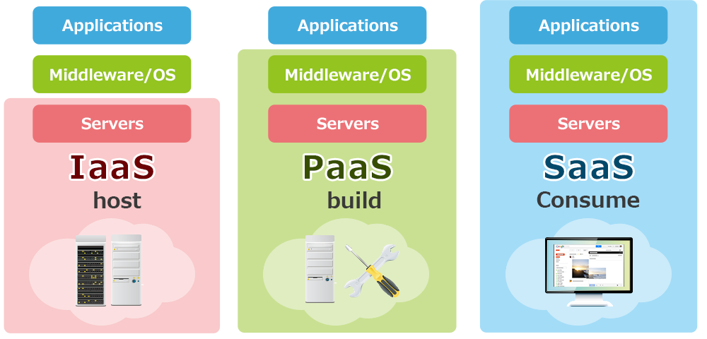

**Cloud Computing: IaaS vs PaaS vs SaaS (Explained with a Pizza)**

Cloud computing has **3 main service models** — like 3 different ways of enjoying pizza:

**1. IaaS (Infrastructure as a Service)**

**Think of it as: Buying a pizza kit** — dough, sauce, toppings — you cook it at home.

* You get raw infrastructure: virtual machines, storage, networks.
* You install and manage the OS, apps, runtime, and data.
* Best for developers who want full control.

**Example:**

* AWS EC2
* Microsoft Azure VMs
* Google Compute Engine

**Use Case:** Hosting websites, setting up custom environments.

**2. PaaS (Platform as a Service)**

**Think of it as: Ordering a half-cooked pizza** — you just add toppings and bake.

* You get an environment to build and deploy applications.
* You don’t worry about hardware, OS, or even runtime.
* Ideal for developers who want to code without managing infrastructure.

**Example:**

* Google App Engine
* Heroku
* Microsoft Azure App Services

**Use Case:** App development, testing, and deployment without managing infrastructure.

**3. SaaS (Software as a Service)**

**Think of it as: Ordering a ready-made pizza** — just open the box and eat!

* You use the software over the internet — no setup, no maintenance.
* Everything is managed by the provider — hardware, software, updates.
* Great for end-users who want functionality right away.

**Example:**

* Google Workspace (Docs, Gmail, Sheets)
* Microsoft 365
* Dropbox, Salesforce, Zoom

**Use Case:** Email, CRM, file storage, communication, collaboration.

**Comparison table**

| **Feature** | **IaaS** | **PaaS** | **SaaS** |
| --- | --- | --- | --- |
| Control | Full control | Some control | Minimal control |
| User | DevOps, sysadmins | Developers | End users |
| Setup Effort | High | Medium | Low |
| Flexibility | Very flexible | Moderately flexible | Not flexible |

**Another Real-Life Example(Owning and Using a Car)**

* **IaaS (Infrastructure as a Service)**  
  Like leasing a car — you get the vehicle (infrastructure), but you are responsible for fuel, maintenance, and driving it.  
  You control the OS, middleware, runtime, and apps, but the cloud provider handles the hardware.
* **PaaS (Platform as a Service)**  
  Like using a taxi — you tell the driver where to go. You don’t worry about fuel, maintenance, or navigation.  
  You focus on writing and deploying code; the provider manages the OS, servers, and runtime.
* **SaaS (Software as a Service)**  
  Like taking the bus — the route and service are predefined. You just get on and use it.  
  You simply log in and use the application. No infrastructure or platform management needed.